**Art Career Insights Platform: Problem Statement**

**Group Name: Team Artists- Team 20**

**Group Members:**

Akhila Karka

Durga Naveen Kantipudi

Harshitha Kapalavayi

Mounika Karumuri

Vuturi Bhargavi

Yashaswini Kasanagottu

**Problem Statement**

**Optimizing Freelance Art Careers Using Available Datasets**

Freelance artists and creative professionals often struggle to find reliable and data-driven insights into job market trends, salary benchmarks, and skill demands. The Art Career Insights Platform aims to optimize career decision-making by leveraging the available Upwork Freelance Jobs Dataset (January 2022) to provide insights into:

* Freelance job trends based on Upwork job postings
* Salary benchmarks for different artistic roles using fixed-price job data
* Demand patterns for creative skills based on job listings

This platform will serve art professionals, students, and recruiters by consolidating industry-relevant data, enabling well-informed career and hiring decisions.

**Decision-Maker and Requirements**

**Primary Decision-Makers:**

* Freelance artists and designers
* Art recruiters and HR professionals
* Art school mentors and career advisors
* Art gallery managers and museum curators
* Creative entrepreneurs

**Decision-Making Needs:**

* **Talent Demand Forecasting:** Identifying in-demand artistic disciplines.
* **Salary & Pricing Insights:** Providing real-time insights into earnings.
* **Creative Career Path Planning:** Predicting hiring needs and industry changes.
* **Emerging Market Trends:** Analyzing industry movements in digital and traditional arts.

**Key Components & Data Mapping**

The following table outlines the key platform modules and their relevant data fields.

**Key Components & Data Mapping Table**

| **Component of Problem Statement** | **Module to Include** | **Relevant Data (Variables/Fields)** |
| --- | --- | --- |
| **Freelance Job Trends** | Job Trends Dashboard | Job Title |
| **Salary Insights** | Salary Visualization | Job Title, Salary |
| **Skills in Demand** | Skills Analysis | Skills |
| **Market Trends** | Trend Forecasting | Employment_Type |

**Data Tables & Variables**

The following table lists specific datasets, tables, and fields from the project.

**Datasets and Variables**

|  |  |  |  |
| --- | --- | --- | --- |
| **Dataset Name** | **Table Name** | **Variable** | **Data Type** |
| Job Market Dataset | Jobs | Job_ID | Integer (Primary Key) |
|  |  | Title | Text |
|  |  | Salary | Text |
|  |  | Description | Text |
|  |  | Applicant_Count | Text |
|  |  | Skills | Text |
|  |  | Employmenttype | Text |
|  |  | Links_Href | Text |
| Company Dataset | Companies | Company_ID | Integer (Primary Key) |
|  |  | Company_Name | Text |
|  |  | Location | Text |
| Relationship Dataset | Job_Company_Relationship | Job_ID | Integer (Foreign Key) |
|  |  | Company_ID | Integer (Foreign Key) |

**1. Check Foreign Key Enforcement (Must be Enabled)**

Before checking referential integrity, ensure that foreign key constraints are enabled in SQLite.



If this returns 0, foreign key constraints are not enabled.

**Check for Orphan Records (Referential Integrity Issues)**

These queries will help you find broken foreign key references in your tables.

Check for Job_ID in Job_Company_Relationship that doesn’t exist in Jobs

it means there are Job_ID values in Job_Company_Relationship that do not exist in Jobs.

Check for Company_ID in Job_Company_Relationship that doesn’t exist in Companies

It means there are Company_ID values in Job_Company_Relationship that do not exist in Companies.

**Field level Integrity**

Check if there are any null values in the important columns

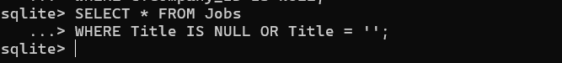

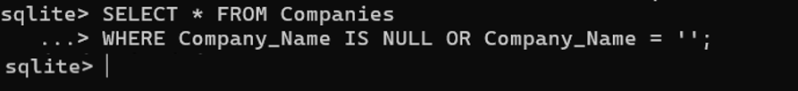

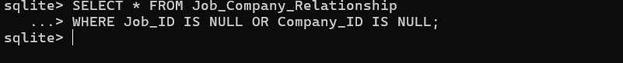

**Process Used**

Create table Jobs

Create Companies table

Create table Job_Company_Relationship

View the first few rows from the Jobs table

View the first few rows from the companies table

**Generative AI:**

How can I change this assignment as per my new dataset I have   
How to split the data into multiple files